

CS-250: Lab 3
Implementation of Linked List with its Operations

Muhammad Mujtaba
CMD ID: 540040
mmujtaba.bese25seecs@seecs.edu.pk

  - Class: BESE 16B
  - Batch: 2k25
Github Repo Link: https://github.com/mmujtaba25/CS-250
Zip File for only Lab 03 (Auto generated): https://github.com/mmujtaba25/CS-250/releases/tag/cs-250-lab-03-540040

Task 1:
Since the files are large, GitHub links for them are provided below:
See linked_list.hpp and linked_list.cpp.

Task 2:
See linked_list.cpp#L76

Task 3:
A ForEach Function was exposed that can be used to print in any way required.
linked_list.cpp#L226
Usage to print:
menu.cpp#L60

Task 4:
Using a removeIf function we can remove any specific element from the list given a predicate.
linked_list.cpp#L125 (removeIf)
See menu.cpp#L33, here we allow the user to give input in the form of “<value>”, “:<index>” or “:” (removes the last element):
menu.cpp#L184 (parsing)
menu.cpp#L87 (removing)
menu.cpp#L249 (user input)

Task 5:
See linked_list.cpp#L190

Task 6:
See menu.cpp and menu.hpp.

Task 7:
We use private inheritance form C++ to make sure only we can call methods for insertion and other stuff from LinkedList class and caller has access to only said function.
See queue.cpp and queue.hpp.
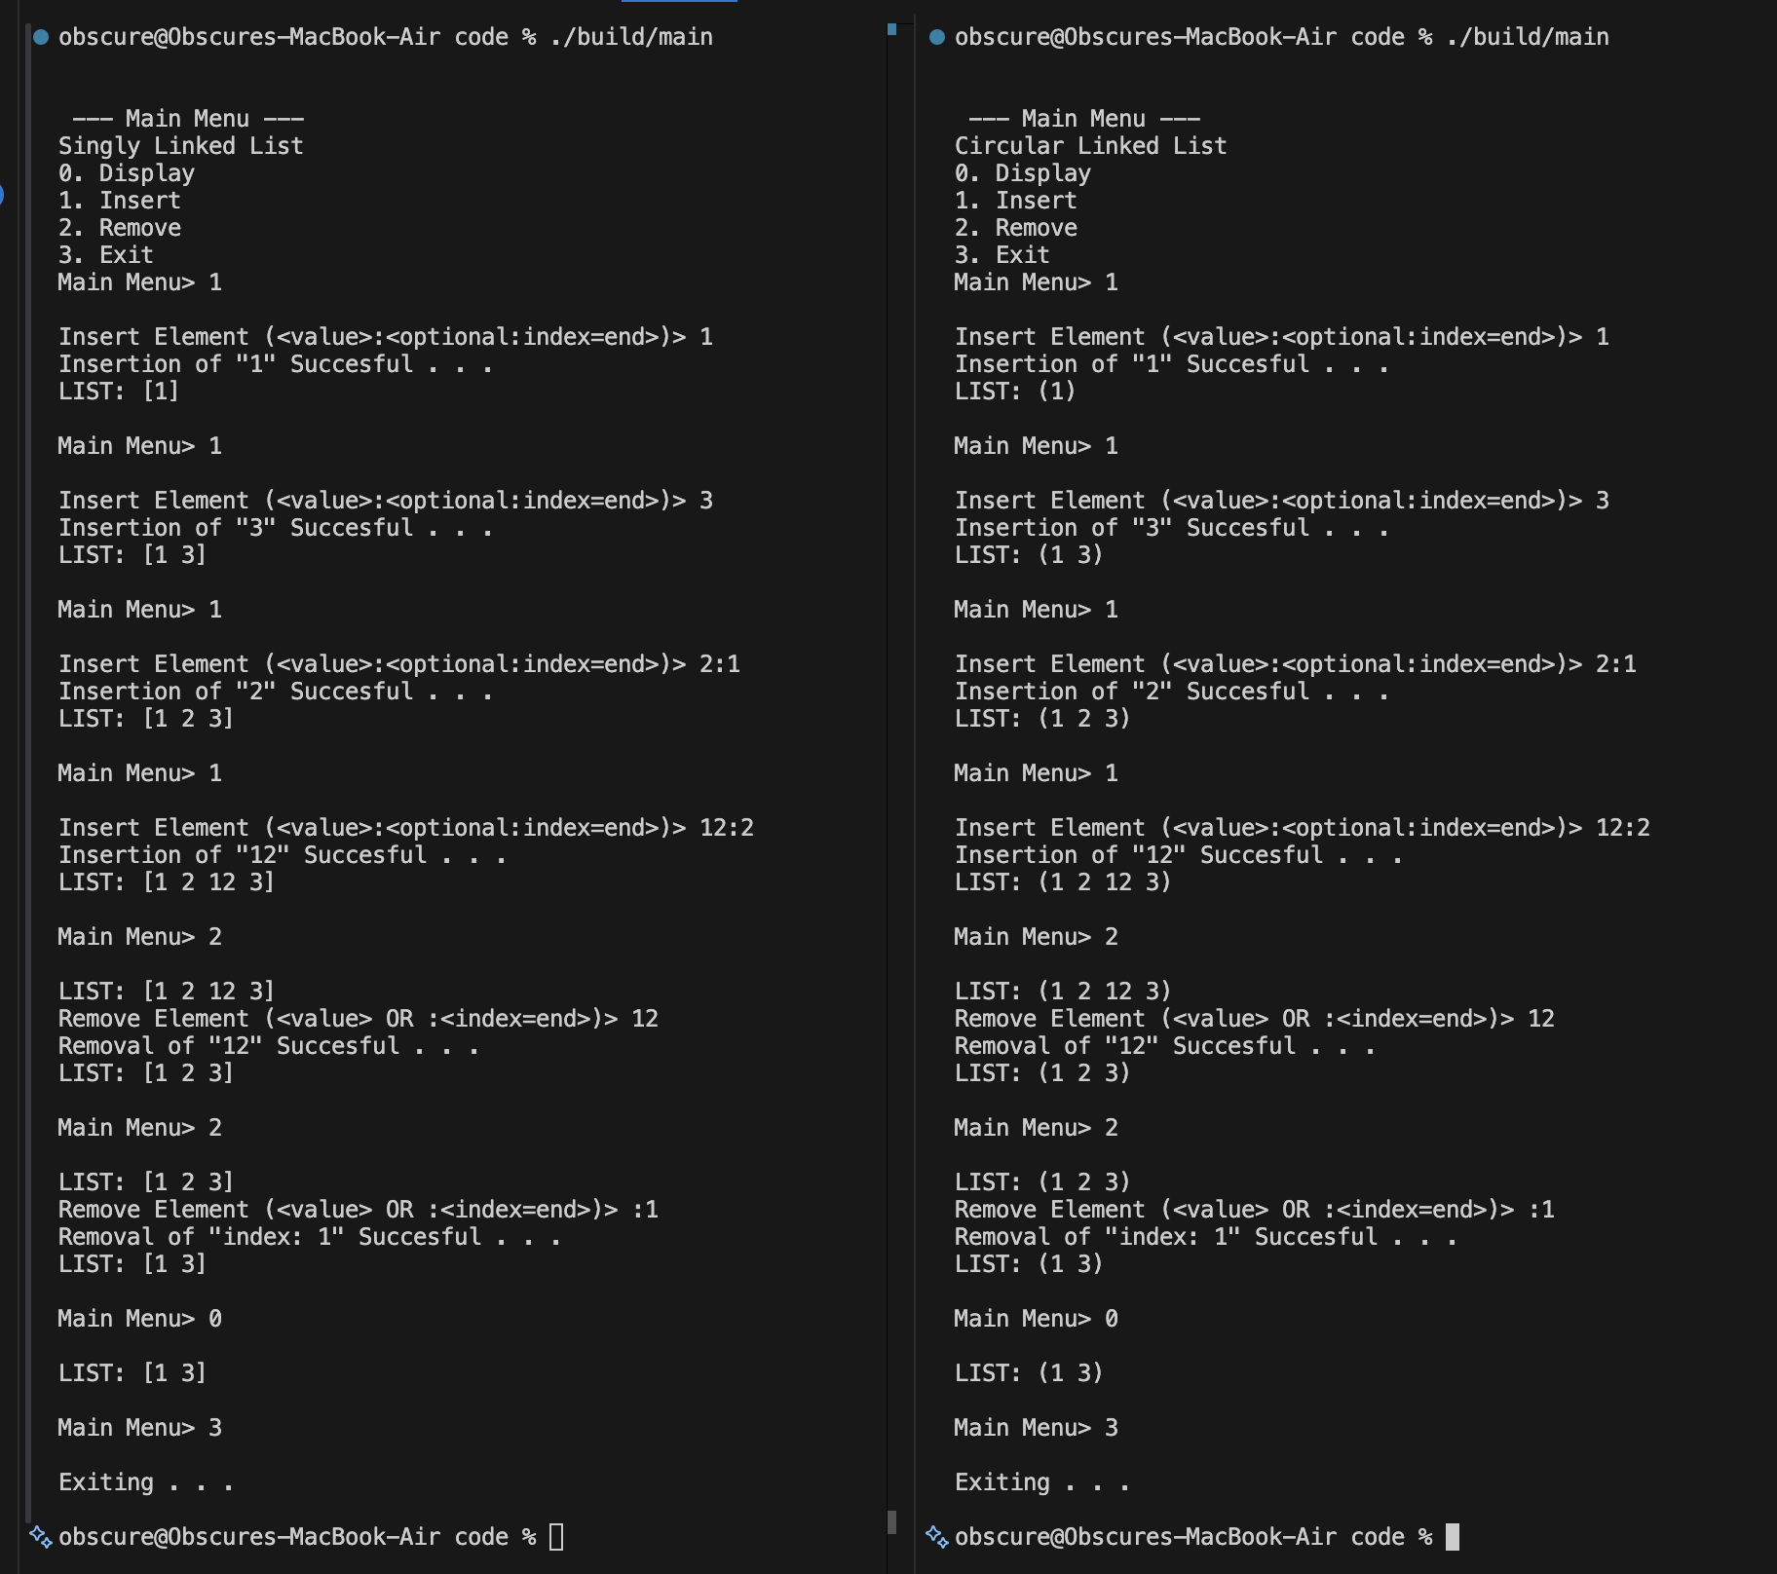
Working Menu, [Left: Singly Linked List] & [Right: Circular Linked List]

Task 8:
For circular linked list, most of the source is the same, except for change requiring the last element to point towards the first element.
See circular_linked_list.cpp and circular_linked_list.hpp.
Using VS Code Compare we can see the code difference between [circular_linked_list.cpp and circular_linked_list.hpp] and [linked_list.hpp and linked_list.cpp]
Diff in insertAt Function:
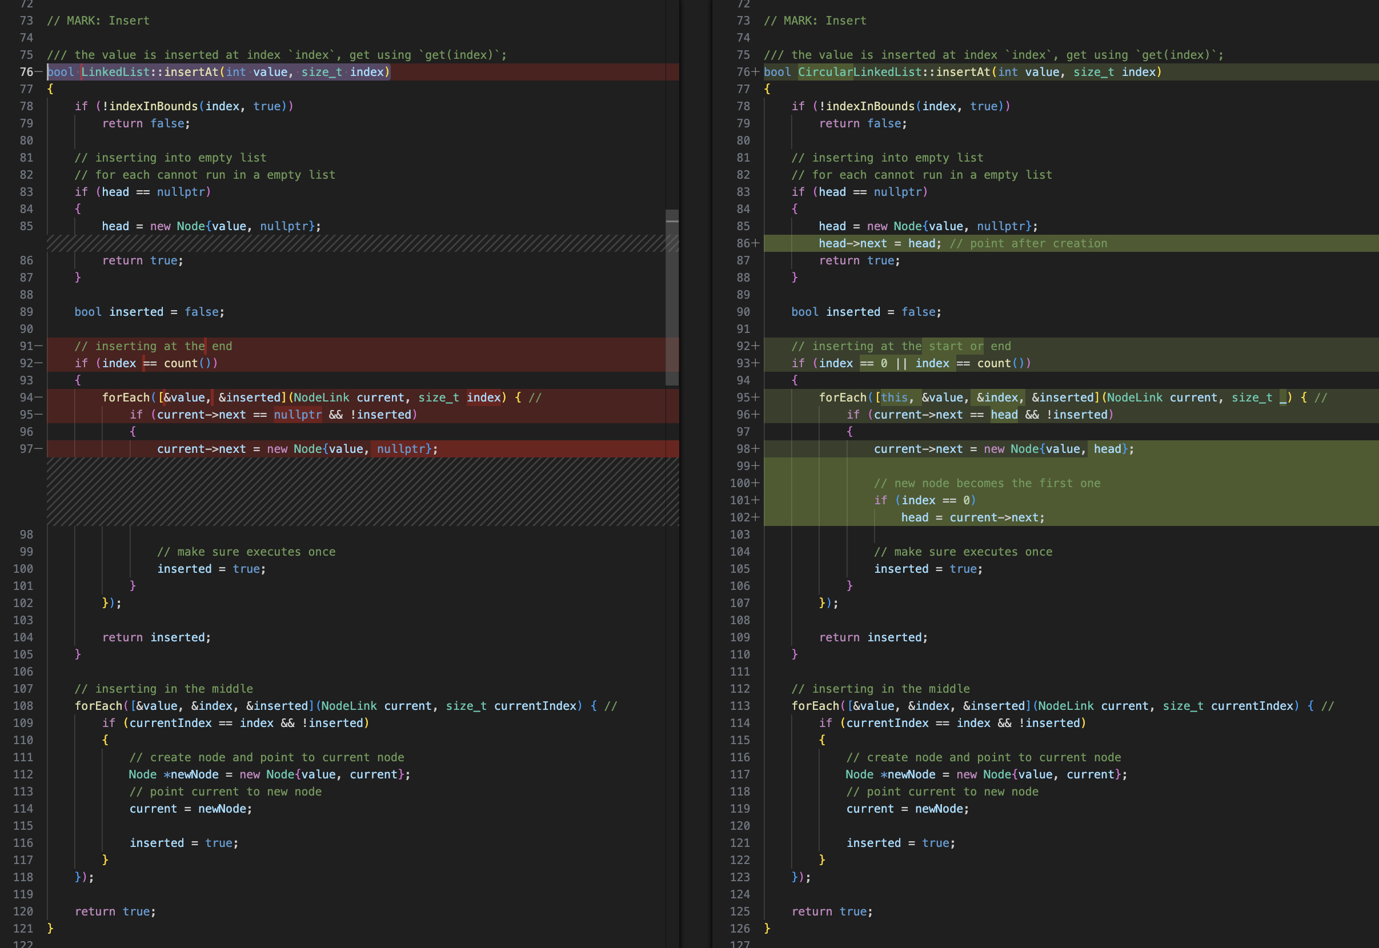

Diff in removeIf Function:
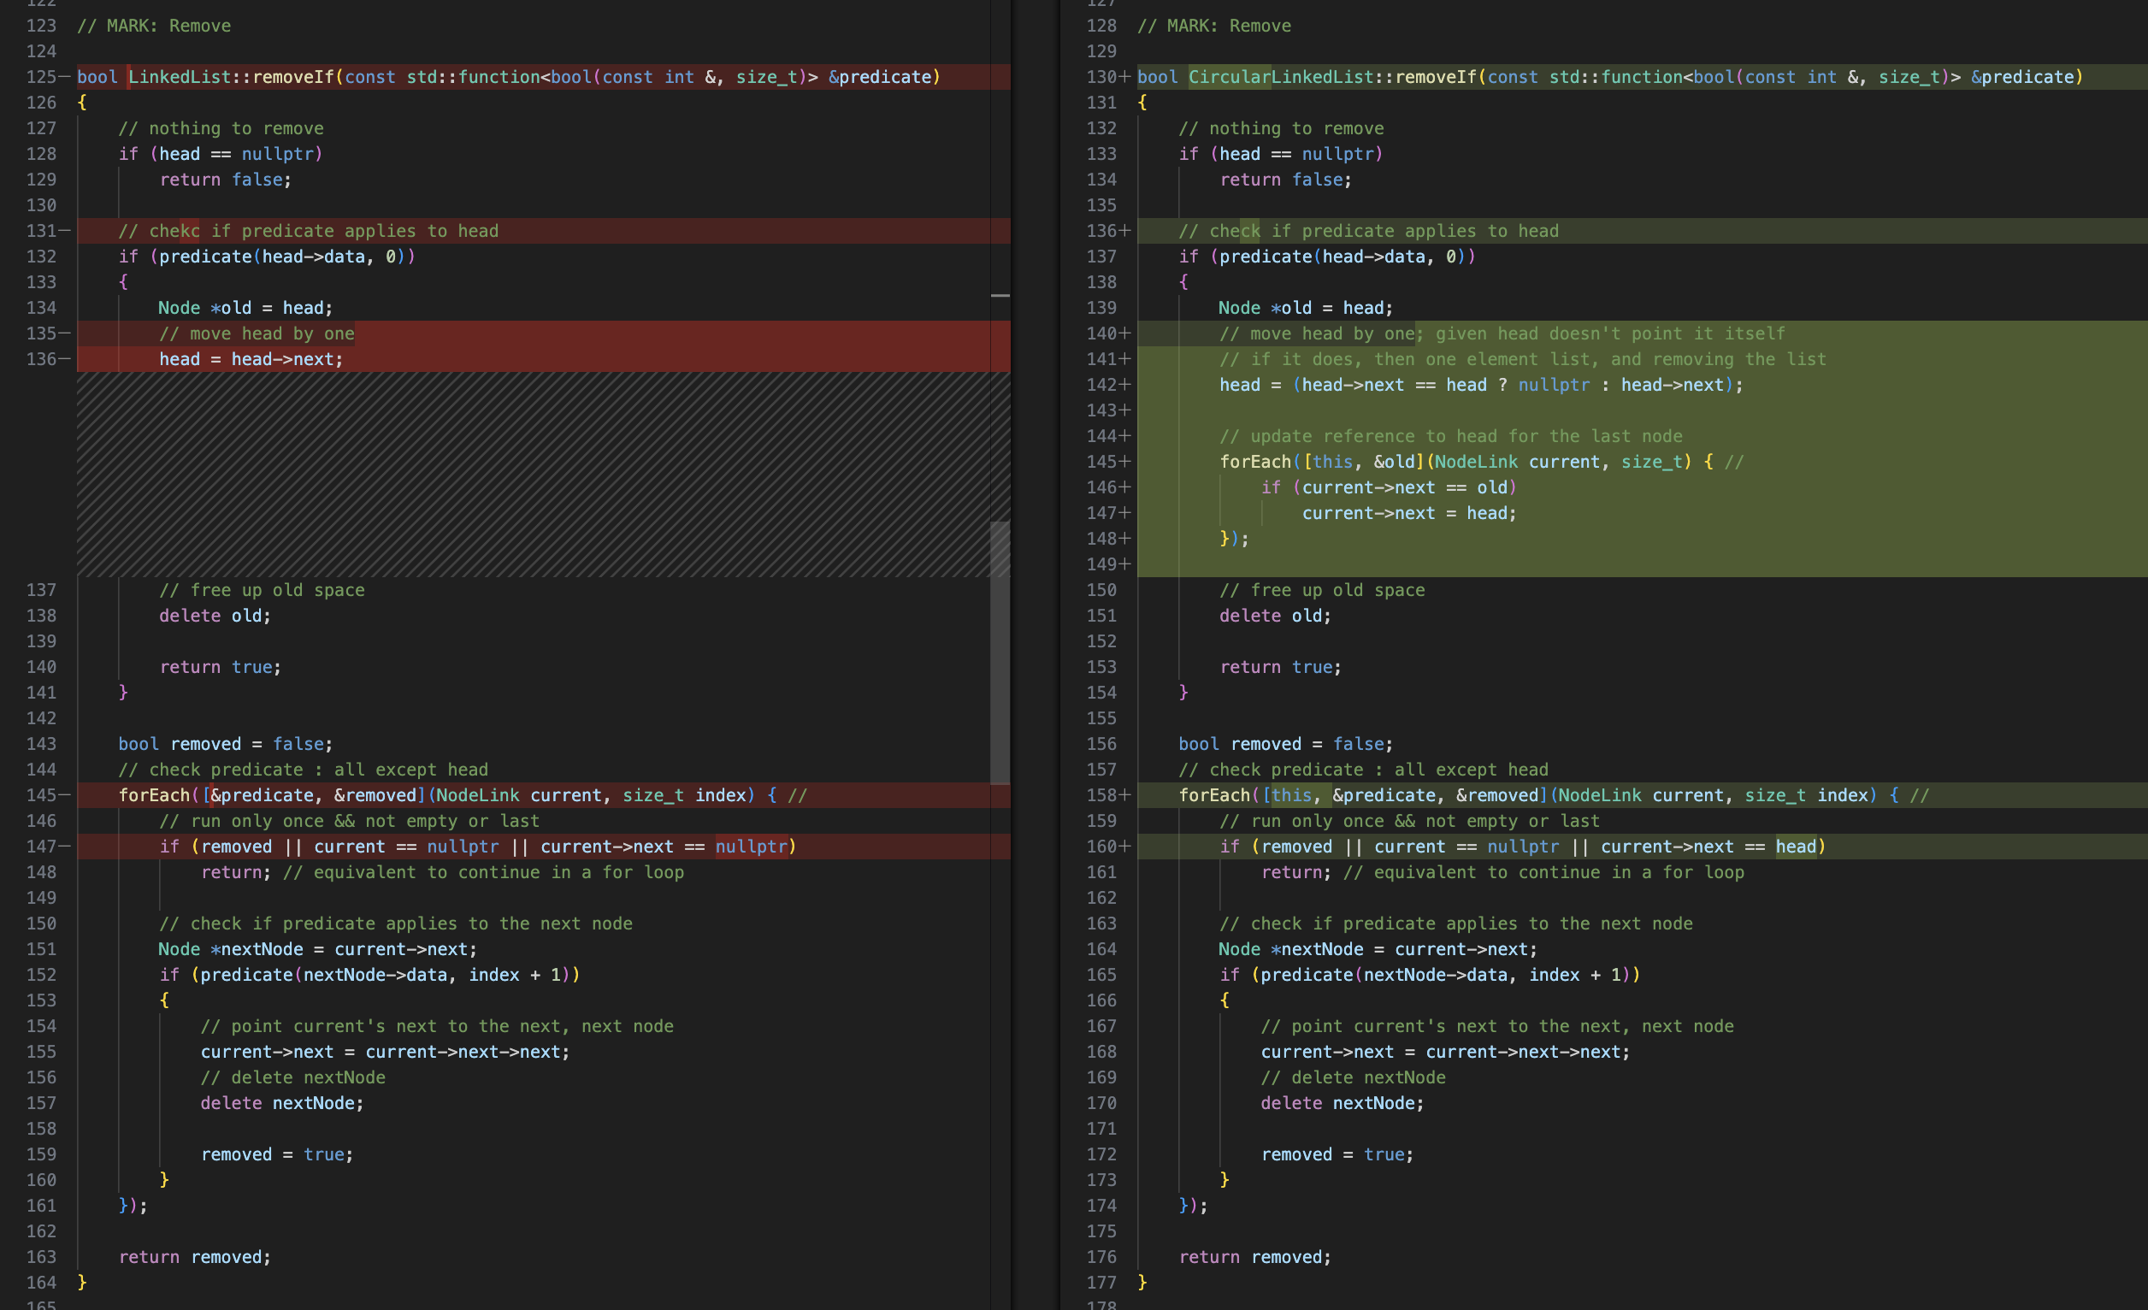
Diff in removeAll Function:
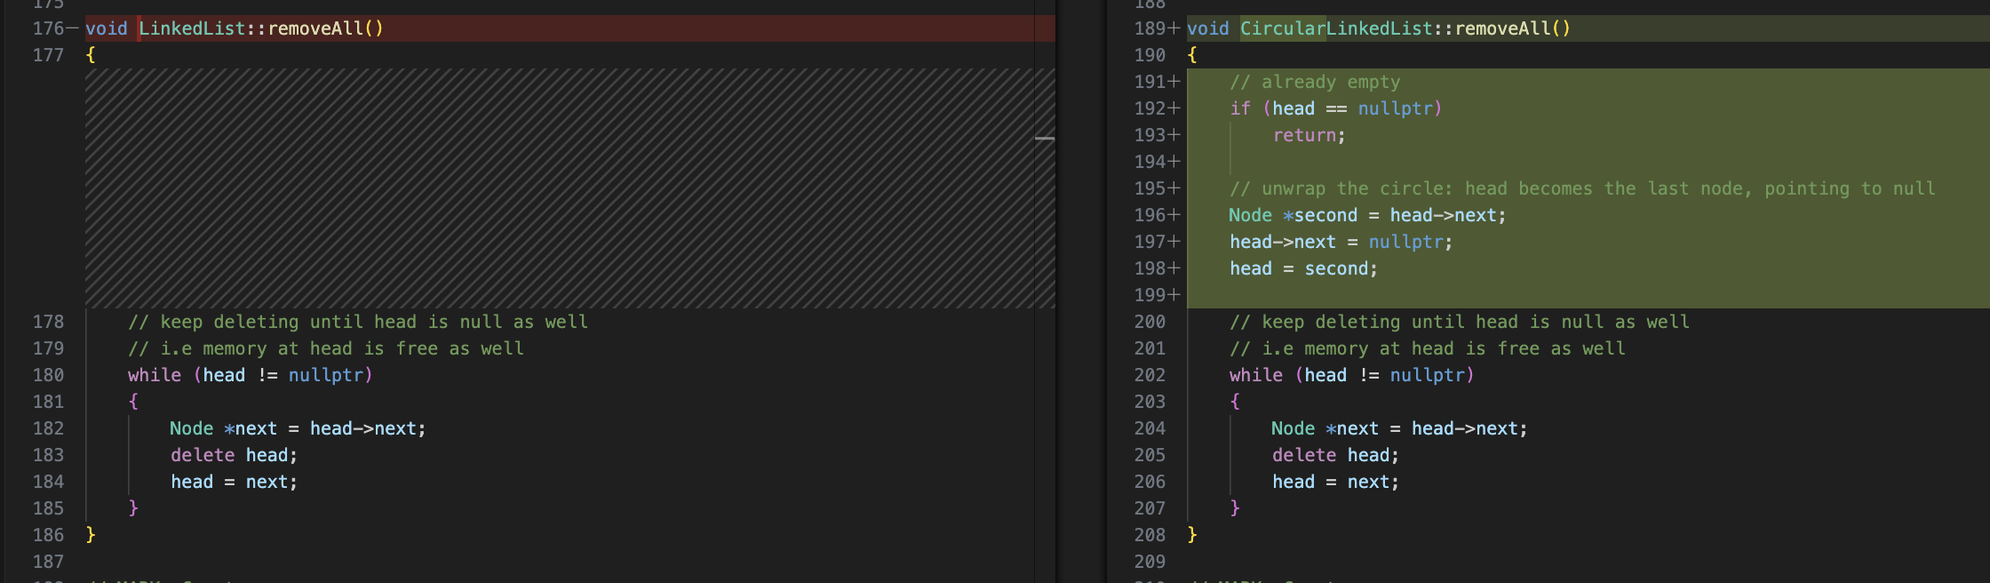

Diff in forEach Functions:
